

**Assignment – 2**

* **Connect to the Store Sales Data and do the following: -**
  + *Remove all the blank rows.*

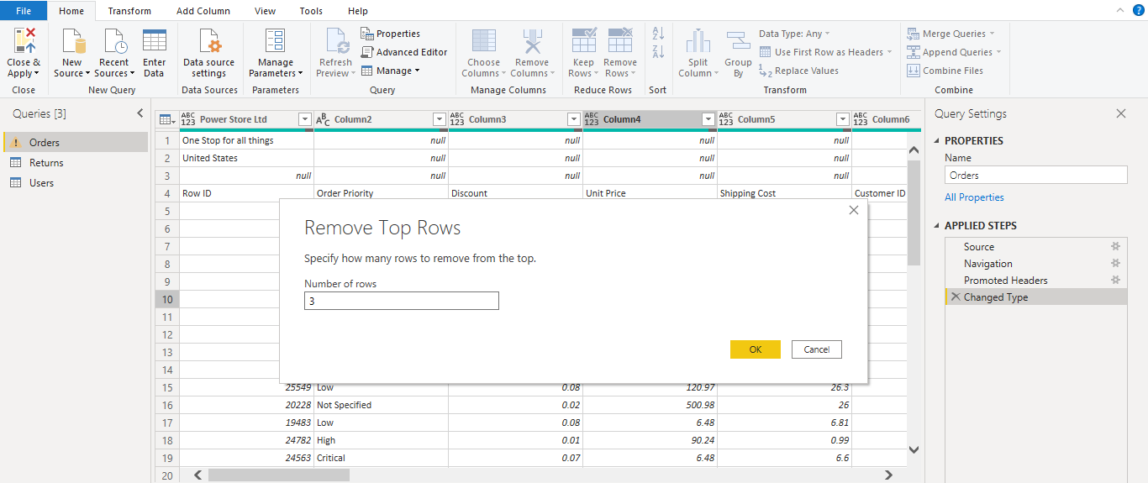

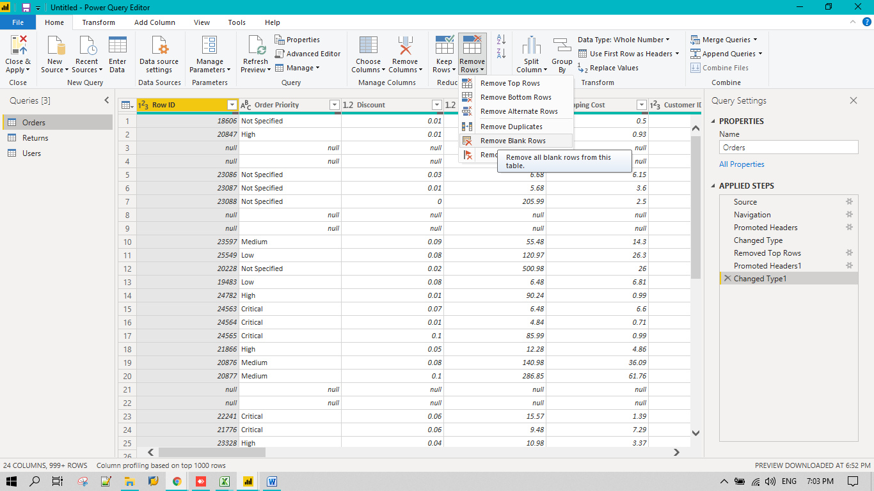

* + *Update the column header if they are not updated*

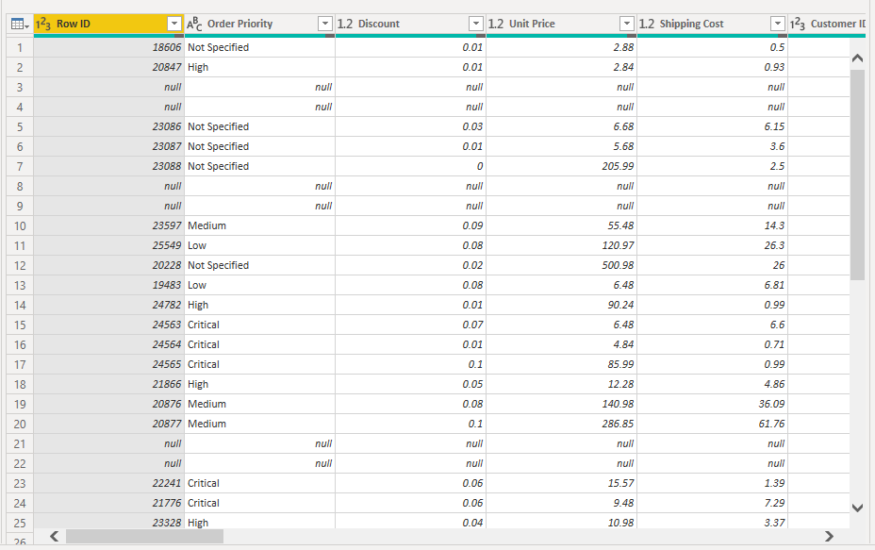

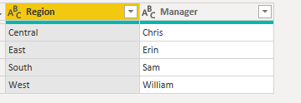

* + *Create a text table and show the sales in terms of*
    - *Customers - Sorted based on sales*

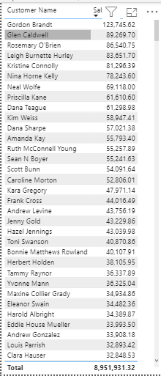

* + - *Product Category*

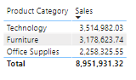

* + - *Regions*

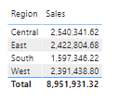

* **Create a line and Clustered Column Chart showing the Sales and Discount as per the State or Province**

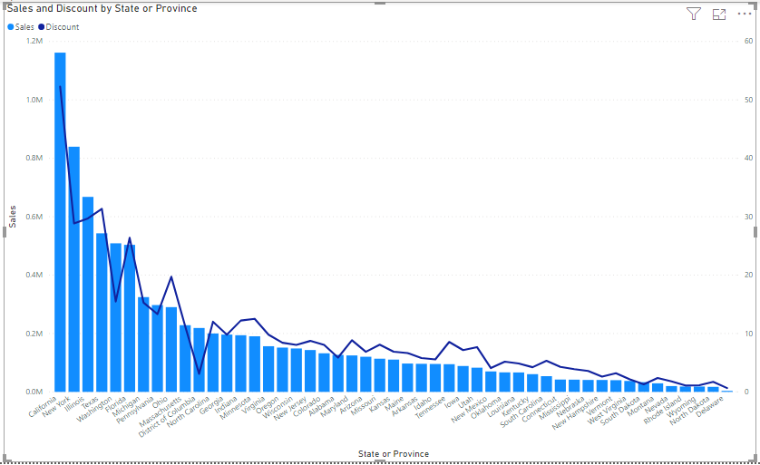

* + *Format the bars and line with different colors*

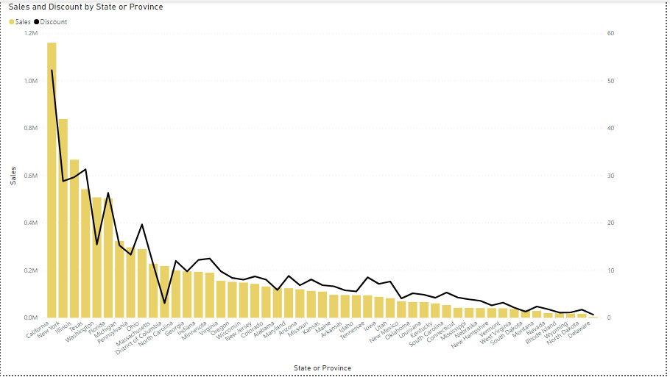

* + *Which state has the highest sales in terms Technology*
    - *New York with 397k sales recorded*

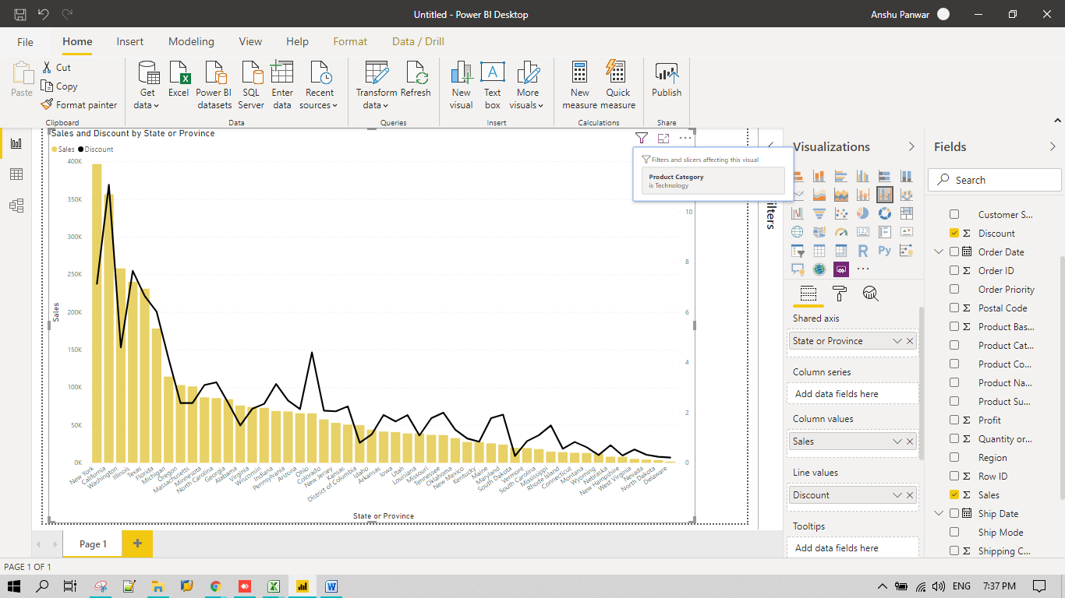

* **Create a** *Donut Chart* **showing sales in terms of Product category**

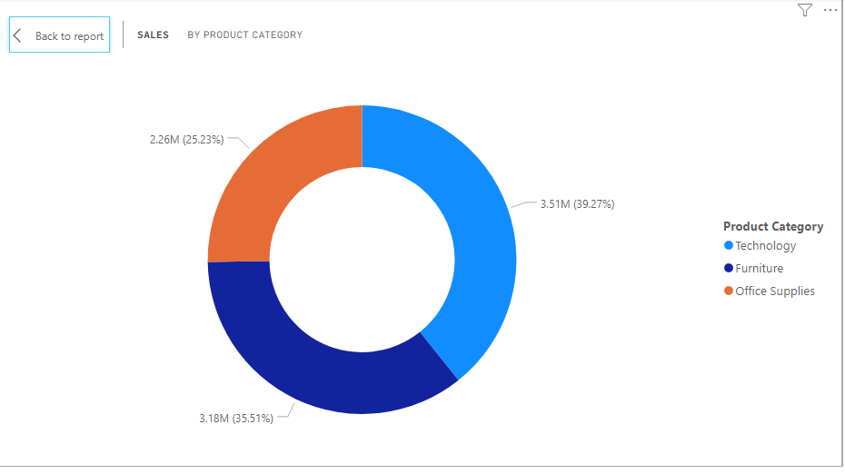

* **Create a** *Slicer* **and show the regions in dropdown. See how all the visuals mentioned above behaving when a particular region is selected.**
  + Region selected is central

